Majid Almislim 202100688

Software Testing & Quality Assurance 102

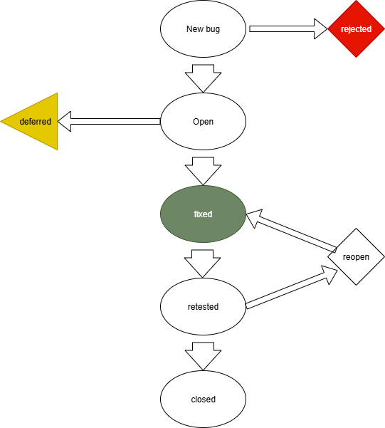

1. New bug is introduced, could be by developer or user
2. Bug is reviewed, if not a real bug then rejected
3. Real bugs are opened for review
4. Some bugs can be deferred to other programmers for fixing if necessary
5. Programmer can attempt to fix bug
6. Replicates original bug conditions and tests to see if bug is still present
7. If still present or worsened, bug is reopened and fixed again
8. Otherwise, bug is closed permanently